ASSIGNMENT -1

SMART HOME USING IOT

Team ID: PNT2022TMID38668

Team member name: Sivasangari P

Assigned on: 12.09.2022

Uploaded on: 16.09.2022

CODE

#include <Servo.h>

int dist = 0;

int temp = 0;

int tempconversion = 0;

int gas = 0;

int PR = 0;

int photoresistor = 0;

int button = 0;

long readUltrasonicDistance(int triggerPin, int echoPin)

{

pinMode(triggerPin, OUTPUT); // Clear the trigger

digitalWrite(triggerPin, LOW);

delayMicroseconds(2);

// Sets the trigger pin to HIGH state for 10 microseconds

digitalWrite(triggerPin, HIGH);

delayMicroseconds(10);

digitalWrite(triggerPin, LOW);

// Reads the echo pin, and returns the sound wave travel time in microseconds

return pulseIn(echoPin, HIGH);

}

Servo servo_8;

void setup()

{

pinMode(A0, INPUT);

pinMode(7, INPUT);

pinMode(A2, INPUT);

pinMode(A1, INPUT);

pinMode(10, OUTPUT);

servo_8.attach(8, 500, 2500);

pinMode(9, OUTPUT);

pinMode(6, OUTPUT);

pinMode(5, OUTPUT);

pinMode(13, OUTPUT);

Serial.begin(9600);

}

void loop()

{

dist = 0.01723 * readUltrasonicDistance(12, 11);

temp = (-40 + 0.488155 * (analogRead(A0) - 20));

PR = digitalRead(7);

gas = analogRead(A2);

photoresistor = analogRead(A1);

if (dist <= 100) {

if ((-40 + 0.488155 * (analogRead(A0) - 20)) > 16) {

digitalWrite(10, HIGH);

} else {

digitalWrite(10, LOW);

}

servo_8.write(90);

if (photoresistor < 800) {

if (dist < 100) {

digitalWrite(9, HIGH);

}

} else {

digitalWrite(9, LOW);

}

} else {

digitalWrite(10, LOW);

servo_8.write(0);

digitalWrite(9, LOW);

}

if (PR == HIGH) {

digitalWrite(6, LOW);

} else {

digitalWrite(6, HIGH);

}

if (photoresistor < 800) {

digitalWrite(5, HIGH);

} else {

digitalWrite(5, LOW);

}

if (gas > 180) {

if (temp > 45) {

digitalWrite(13, HIGH);

Serial.println("Fire Alarm");

} else {

digitalWrite(13, HIGH);

Serial.println("Gass Leakage");

}

} else {

digitalWrite(13, LOW);

}

delay(10); // Delay a little bit to improve simulation performance

}

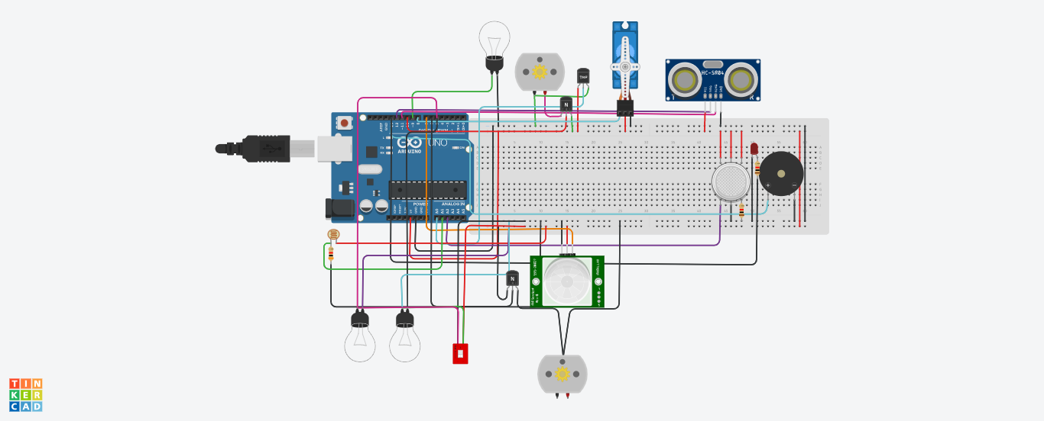

Circuit view

Sensor and components used in the circuit are given below

* + - * Ardunio UNO
      * Micro servo
      * PIR Sensor
      * LED lights
      * Piezeo
      * Light lub
      * resistors